BIMM 143

## Quarto

Quarto enables you to weave together content and executable code into a finished document. To learn more about Quarto see <https://quarto.org>.

plot(1:10)

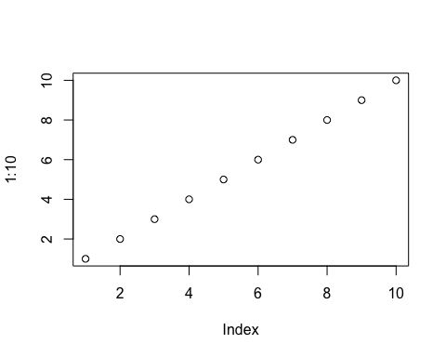

## Running Code

When you click the **Render** button a document will be generated that includes both content and the output of embedded code. You can embed code like this:

1 + 1

[1] 2

You can add options to executable code like this

[1] 4

The echo: false option disables the printing of code (only output is displayed).